5^{h} Sunday of Lent

March 26, 2023 10:00 AM

WE GATHER TO WORSHIP GOD

CHIMING THE HOUR

WELCOME AND ANNOUNCEMENTS

PRAYER OF APPROACH

PRELUDE: “Beyond the Willow” - Elizabeth Webb Kathy Bowen, Harpist

CALL TO WORSHIP (from Psalm 130) Marty Pond, Liturgist

One: Out of the depths I cry to you, O LORD.
All: Lord, hear my voice!
One: Let your ears be attentive to the voice of my supplications!
All: If you, O LORD, should mark iniquities, Lord, who could stand?
One: But there is forgiveness with you, so that you may be revered.
All: I wait for the LORD, my soul waits, and in his word I hope;
One: my soul waits for the Lord more than those who watch for the morning, All: Lets us worship God together as our souls eagerly wait for the Lord.

*HYMN #485 “To God Be the Glory”

CALL TO CONFESSION If we say that we have no sin, we deceive ourselves, and the truth is not in us. If we confess our sins, God who is faithful and just will forgive us our sins and cleanse us from all unrighteousness.

PRAYER OF CONFESSION (UNISON)
Forgiving Lord, we have fallen short time and time again. You have given us your word, both in scripture and in your Son. You have promised us your presence, both in Spirit and in community. You have graced us with your kingdom, both in teaching and in service. Even
SERMON “Two Days Longer” Rev. Kirsty H. Dickson-Maret

WE OFFER OUR LIVES TO GOD

AFFIRMATION OF FAITH: The Apostles’ Creed
I BELIEVE in God the Father Almighty, Maker of heaven and earth,
And in Jesus Christ his only Son our Lord; who was conceived by
the Holy Ghost, born of the Virgin Mary, suffered under Pontius Pilate,
was crucified, dead, and buried; he descended into hell; the third day he rose again from the dead; he ascended into heaven, and sitteth on the right hand of God the Father Almighty; from thence he shall come to judge the quick and the dead.
I believe in the Holy Ghost; the holy catholic Church; the
communion of saints; the forgiveness of sins; the resurrection of the
body; and the life everlasting. Amen.

*HYMN # 85 “What Wondrous Love is This”

JOYS AND CONCERNS

PRAYERS OF THE PEOPLE and THE LORD’S PRAYER

CALL FOR THE OFFERING
Every good thing is a gift from God — the food we eat, the things we have, the time we spend, our whole lives. We give our lives back to God as a way of saying thank you — sharing money with those who are in need, giving food to those who are hungry, and spending our time to help others. Let us gladly give or tithes and offerings.

OFFERTORY

DOXOLOGY (tune is Old Hundredth)

PRAYER OF DEDICATION (UNISON)
Blessed are you, God of all creation; through your goodness we have these gifts to share. Accept and use our offerings for your glory and for the service of your kingdom. Blessed be God forever and ever. Amen.

*HYMN # 316 “Breathe on Me, Breath of God”

CHARGE

BENEDICTION

POSTLUDE ~ ~ ~

*For those who are able, please stand.

- Today’s Usher: Bea Boak
- Coffee Hour: today is hosted by Marty Pond
- Deacons: March 28, 7 p.m. in the Media Center (the date has changed)
- Christian Education Committee: March 29, 4:30 p.m., Media Center
- Special Gifts Committee: March 29, 6:30 p.m. Media Center
- Palm/Passion Sunday: April 2, 10 a.m. Worship
- Maundy Thursday: April 6, 7:00 p.m. Worship
- Good Friday: April 7, 12 -2 p.m. Prayerful Meditation in the Sanctuary

Remember in Your Prayers & Correspondence

Ralph Cowdery; Nancy Dobbins; Mimi Dundon; Lillian Olsen

Church Office: Education Center, 64 Oswego St., Baldwinsville, NY Website: presbville.com
9am – 2pm M-F Phone 315-635-9964 Fax 315-638-4792

Pastor-----------------Rev. Kirsty H. Dickson-Maret Clerk of Session------------Stephanie Stine
Director of Music & Choirs--------------Rheta Jenks Organist----------------------–Lee Johnston
Deacon Moderator-----------------------Marty Pond Administrative Assistant---Elizabeth Bayer
Financial Secretary---------------Andrea Ducharme Treasurer---------------------Diana Anastas
Nursery School Director--Jessica Newcomb

First Presbyterian Church
Baldwinsville, NY

March 26, 2023
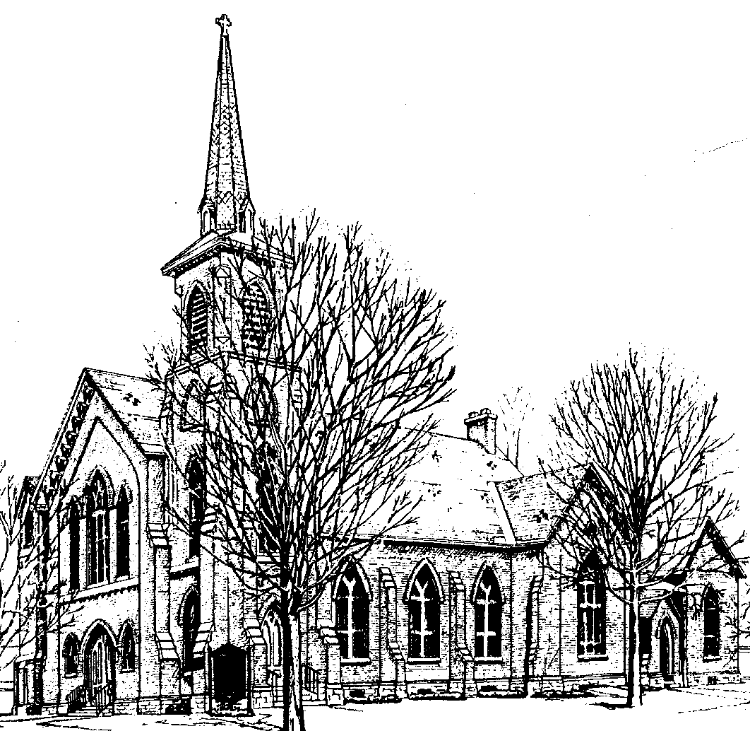

Identity Statement

We are a loving family of God, following Christ by practicing our legacy of worship, education, and mission to neighbors.

so, we neglect, ignore, and reject your purposes for us. We do not love what you love. We do not embrace what you embrace. We do not defend what you have called us to defend. Have mercy on us, O God of all ages past and all hope for years to come. Forgive us for what we do and what we fail to do. And with your gifts, promises, and grace, continue working in our lives that we might receive full life in Jesus Christ, now and forevermore. Amen.

One: Now that we have confessed as a body, let us take the truths that have troubled our hearts to God silently. Let us not be worried about the awkwardness of silence, as we take some time to focus on speaking with our God.

SILENT CONFESSION

WORDS OF ASSURANCE

*CONGREGATIONAL RESPONSE Gloria Patri #579

PASSING OF THE PEACE
One: Since God has forgiven us in Christ,
let us forgive one another.
The peace of our Lord Jesus Christ be with you all.
All: And also with you.
One: Let us share signs of peace with one another.

WE HEAR AND REFLECT ON GOD’S WORD

OLD TESTAMENT LESSON Ezekiel 37:1-14 Liturgist
red Bible p.1052, black Bible p.806

MUSICAL OFFERING

NEW TESTAMENT LESSON John 11:1-45 Rev. Kirsty H. Dickson-Maret
red Bible p. 1307, black Bible p. 104

(2)

Mark Your Calendars for Upcoming Events!

COMMUNITY DINNER

Thursday, April 6, 2023
4:00 – 5:15

Ham & Scalloped Potato Casserole
Lemon Glazed Carrots
Waldorf Salad
Rolls & Butter
Assorted Cakes

Free Meal for All!

Sit-down dinner with Take-out available

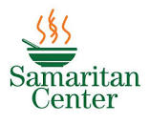

Volunteer to Serve Lunch at the Samaritan Center

Sunday, April 30 at 12:30 – 3:00

If you would like to carpool, we will be leaving the Church parking lot at 12:00. Please contact Kathy Bowen if you would like to join at kathyharp1626@gmail.com or 315 638 8749.

