5th Sunday of Easter

May 15, 2022 10:00 AM

WE GATHER TO WORSHIP GOD

CHIMING THE HOUR

WELCOME AND ANNOUNCEMENTS

PRELUDE

CALL TO WORSHIP Doug Russell, Liturgist

One: Imagine…
All: a place where all are welcome and everyone hears the sound
of their name.

One: Imagine…
All: everyone having enough food and water and a home free of hatred and fear.

One: Imagine…
All: a place where creativity is valued and the spirit is nurtured in love.

One: Imagine… … just imagine this is that place.
All: With one voice, one joy, one faith, one love we worship God together.

*HYMN #455 “All Creatures of Our God and King”

CALL TO RECONCILIATION Liturgist
We know nothing can separate us from God’s love in Christ, so we are free to confess our need of grace.

NEW TESTAMENT LESSON Acts 11:1-8 Rev. Dr. Carson O. Mouser
red Bible pg. 1340, black Bible pg. 130

SERMON “God’s New Heaven and New Earth” Rev. Dr. Carson O. Mouser

WE OFFER OUR LIVES TO GOD

*HYMN #343 “Called As Partners in Christ’s Service”

JOYS AND CONCERNS

PRAYERS OF THE PEOPLE

LORD’S PRAYER (UNISON)
Our Father, who art in heaven, hallowed be thy name. Thy kingdom come, thy will be done, on earth as it is in heaven. Give us this day, our daily bread. And forgive us our debts, as we forgive our debtors. And lead us not into temptation, but deliver us from evil. For thine is the kingdom, and the power, and the glory, forever. Amen.

CALL FOR THE OFFERING
God calls upon us to love one another as God loves us. Even as God has abundantly blessed us with good things let us bless others through offerings that show we care.

OFFERTORY

*DOXOLOGY (tune is Old Hundredth) *HYMN #592

PRAYER OF DEDICATION (UNISON)
Giver of Life, we share what we have received. We dedicate these gifts as we rededicate ourselves to preparing the way for a new heaven and renewed Earth, where all people and all creation know the full measure of your peace. May these gifts reflect a praise and gratitude for the work of your spirit, drawing us ever deeper into the richness of relationship upon which we all depend. Amen.

*CLOSING HYMN #369 “I’m Gonna Live So God Can Use Me”

BENEDICTION

POSTLUDE
~ ~ ~

*For those who are able, please stand.

- Today’s Usher: Heidi Henderson
- Coffee Hour Today: Please join us in the Chancel Hallway after worship for fresh coffee, homemade baked goods, and most importantly - conversation and fellowship with your church family. Today’s hostess is Barb Winegard.
- 3rd Annual Parkinson’s Open House: Today, 11 am – 2 pm, 604 Old Liverpool Road. Contact 315-729-7178 for more information.
- Hungers for Hope Craft Fair: to benefit PNS is Today!
9:30 – 1:30 on the church grounds. Cluck n Seafood n Burger Food Truck will be on site.

Remember in Your Prayers & Correspondence

Barry Bullis; Nancy Dobbins

Church Office: Education Center, 64 Oswego St., Baldwinsville, NY Website: presbville.com
9am – 2pm M-F Phone 315-635-9964 Fax 315-638-4792

Interim Pastor-----------Rev. Dr. Carson O. Mouser Clerk of Session------------Stephanie Stine
Director of Music & Choirs--------------Rheta Jenks Organist----------------------–Lee Johnston
Deacon Moderator-----------------------Marty Pond Administrative Assistant---Elizabeth Bayer
Financial Secretary---------------Andrea Ducharme Treasurer---------------------Diana Anastas
Nursery School Director--Jessica Newcomb

First Presbyterian Church
Baldwinsville, NY

May 15, 2022
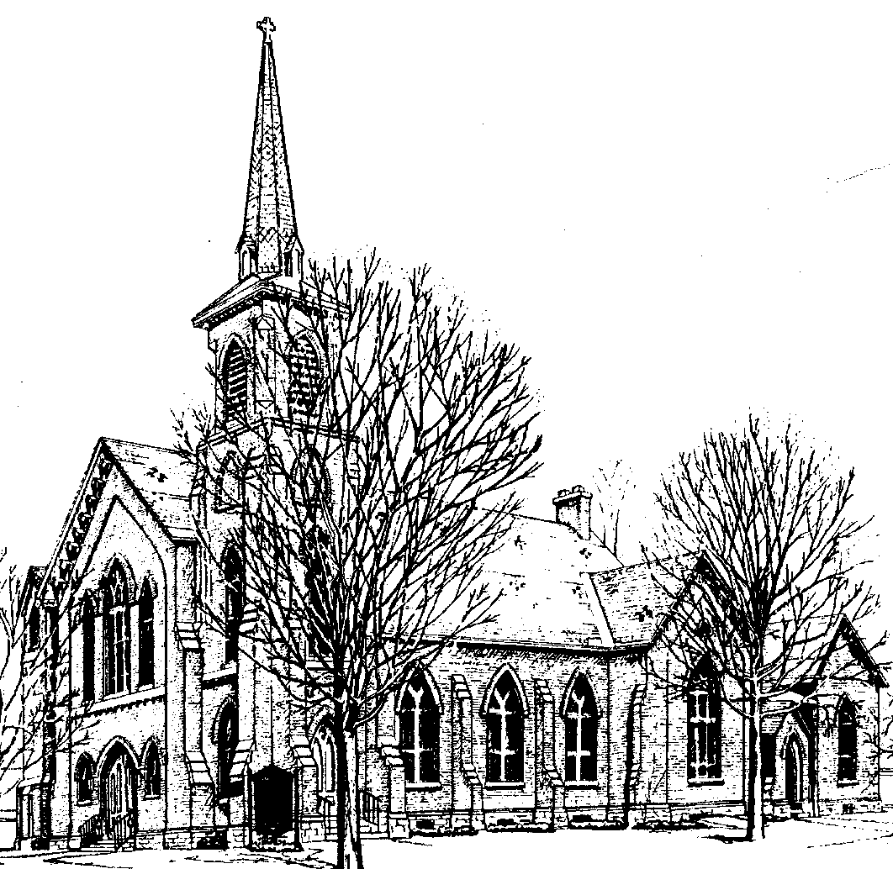

Identity Statement

We are a loving family of God, following Christ by practicing our legacy of worship, education, and mission to neighbors.

PRAYER OF RECONCILIATION (UNISON)

The house of God is our home: a place of comfort, familiarity, of easily held opinions, common causes, and shared values. A community that affirms our beliefs, traditions, understandings of the world. God came to live among us – broke through every barrier of sense, wisdom, and experience to forge a new people, to build a new community without borders or boundaries. Into our quiet complacency or our noisy divisions God suggests another way, breaking down our barriers, crashing through our comfort zones to the heart of what it is to live in God’s way. So, we pause and ponder the inclusion we feel, the exclusion we create, the easy friendships, the like-minded gatherings, the many left outside. Yet what might seem unclean is precious to God. What looks ungodly is counted worthy. Sinners made saints, outsiders pulled in to be warmed at the hearth – the walls of the community pushed out to make room.

SILENT REFLECTION

Forgive us the narrow-mindedness that excludes. Forgive us the tendency to disapprove and judge, and open hearts and arms to the life you promised. Open our doors to make room for those you would welcome.

WORDS OF ASSURANCE
Though we wander from the path, though we step out of the light, though we
embroider the truth, though we deny the fullness of life – despite all this,
Christ comes bearing life, light, truth, and new life to us all. We are made
whole through Jesus the Christ.

CONGREGATIONAL RESPONSE “Gloria Patri” *HYMN #579

WE HEAR AND REFLECT ON GOD’S WORD

OLD TESTAMENT LESSON Psalm 148 Liturgist
red Bible pg. 780, black Bible pg. 582
MUSICAL OFFERING

(2)

