6th Sunday of Pentecost

July 17, 2022 10:00 AM

WE GATHER TO WORSHIP GOD

CHIMING THE HOUR

WELCOME AND ANNOUNCEMENTS

PRELUDE

CALL TO WORSHIP Tricia Adams, Liturgist

One: In the presence of the faithful, let us proclaim God’s name.
All: In the presence of the faithful, let us praise God’s holy name.
One: In times of joy and pain,
All: In the presence of the faithful, let us praise God’s holy name
One: Whether serving at table, or in the streets, or on the mountaintops,
All: In the presence of the faithful, let us praise God’s holy name.
One: In our learning and teaching, and all of our growing,
All: In the presence of the faithful, let us praise God’s holy name.
One: Come, we worship God.

*HYMN “Christ Be Beside Me”

Christ be beside me,
Christ be before me,
Christ be behind me,
King of my heart.
Christ be within me,
Christ be below me,

LORD’S PRAYER (UNISON)
Our Father, who art in heaven, hallowed be thy name. Thy kingdom come, thy will be done, on earth as it is in heaven. Give us this day, our daily bread. And forgive us our debts, as we forgive our debtors. And lead us not into temptation, but deliver us from evil. For thine is the kingdom, and the power, and the glory, forever. Amen.

CALL FOR THE OFFERING
God calls upon us to love one another as God loves us. Even as God has abundantly blessed us with good things let us bless others through offerings that show we care.

OFFERTORY

*DOXOLOGY (tune is Old Hundredth) *HYMN #592

PRAYER OF DEDICATION (UNISON)
We bring to you the fruits of the earth, the work of our hands, and the gifts of our hearts, O God. And with them, we bring a yearning for justice, a passion for good, and a commitment to do your will. May our words and our works help to declare your goodness, we pray. Amen.

*CLOSING HYMN #2175 “Together We Serve”

BENEDICTION

POSTLUDE
~ ~ ~

*For those who are able, please stand.

(4)

- Today’s Usher: Mark Chamberlin
- Coffee Hour today is hosted by Barb Winegard
- Acts of the Apostles Bible Study: Weds., July 20,
7-8:00 p.m. via Zoom. Contact the office for the link.
- Rummage Sale: Donation hours: July 25-Aug 4, 10-2 & 5-6
Sale hours: Fri, Aug 5- 8-6, Sat Aug 6 bag sale 9-12

Remember in Your Prayers & Correspondence

Barry Bullis; Anthonia Todd; Nancy Dobbins

Church Office: Education Center, 64 Oswego St., Baldwinsville, NY Website: presbville.com
9am – 2pm M-F Phone 315-635-9964 Fax 315-638-4792

Interim Pastor-----------Rev. Dr. Carson O. Mouser Clerk of Session------------Stephanie Stine
Director of Music & Choirs--------------Rheta Jenks Organist----------------------–Lee Johnston
Deacon Moderator-----------------------Marty Pond Administrative Assistant---Elizabeth Bayer
Financial Secretary---------------Andrea Ducharme Treasurer---------------------Diana Anastas
Nursery School Director--Jessica Newcomb

First Presbyterian Church
Baldwinsville, NY

July 17, 2022
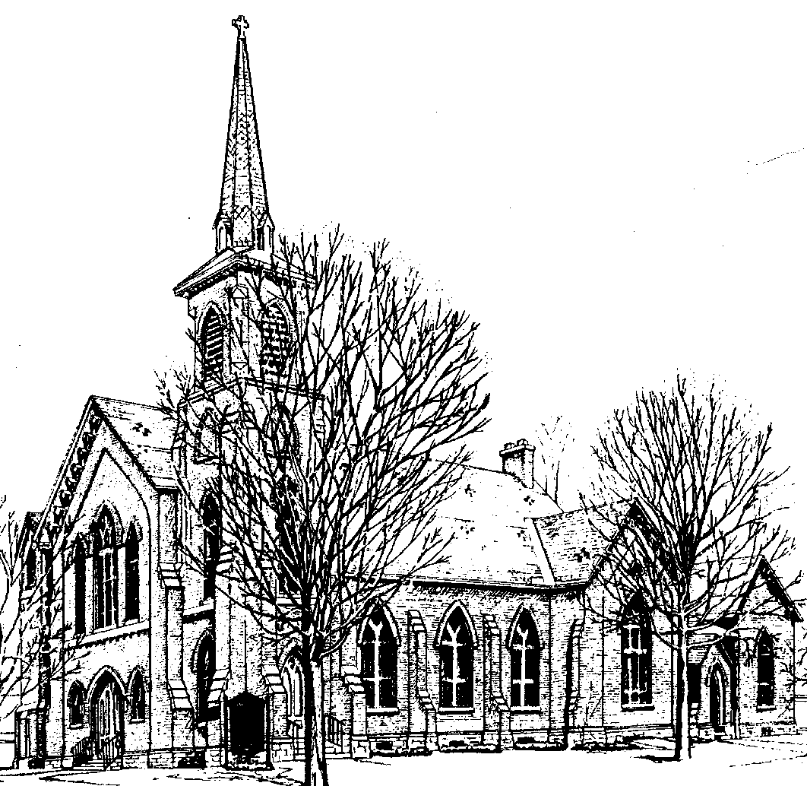

Identity Statement

We are a loving family of God, following Christ by practicing our legacy of worship, education, and mission to neighbors.

Christ be above me,
never to part.

Christ on my right hand,
Christ on my left hand,
Christ all around me,
shield in the strife.
Christ in my sleeping,
Christ in my sitting,
Christ in my rising,
light of my life.

Christ be in all hearts
thinking about me,
Christ be in all tongues
telling of me.
Christ be the vision
in eyes that see me,
in ears that hear me,
Christ ever be.

CALL TO RECONCILIATION
We know nothing can separate us from God’s love in Christ, so we are free to confess our need of grace.

PRAYER OF RECONCILIATION (UNISON)

God of love and patience, we take this moment to pause, and confess those times when we are too busy for you, for one another, and for ourselves. Forgive us when we are too busy to spend time in prayer and listen in our hearts for your word in our lives. Forgive us when we are too busy to notice the needs of others. Forgive us when we are too busy to stop what we are doing and help one another, or laugh with one another, or simply even notice one another. Forgive us when life becomes overwhelming, and we do not even take time for our own needs.

SILENT REFLECTION
Help us to listen to your voice within our hearts, calling us back to center our lives with you.

WORDS OF ASSURANCE
In Christ all the fullness of God was pleased to dwell, making peace with
all things, on earth and in heaven. This same God offers us forgiveness for
all our sins. We are invited to dwell in God’s house, to grow in God’s
garden, to sit at Jesus’ feet. Thanks be to God!

CONGREGATIONAL RESPONSE *HYMN #579 “Gloria Patri”

WE HEAR AND REFLECT ON GOD’S WORD

OLD TESTAMENT LESSON: Psalm 52 Liturgist
red Bible pg. #704, black Bible pg. #521

MUSICAL OFFERING

NEW TESTAMENT LESSON: Luke 10:38-42 Rev. Dr. Carson O. Mouser
red Bible pg. #1263, black Bible pg. #72

SERMON “Listening, Learning, Living” Rev. Dr. Carson O. Mouser

WE OFFER OUR LIVES TO GOD

* HYMN #439 “In Christ There Is No East or West”

JOYS AND CONCERNS

PRAYERS OF THE PEOPLE

(3)

