July 2022 First Presbyterian Church, Baldwinsville, NY accessible facilities

TIDINGS
church office hours Monday – Friday 9 am – 2 pm
church office phone 315-635-9964 nursery school 315-635-7391 fax 315-638-4792 website presbville.com

,,,,

published in the Church Office editor/admin - admin@presbville.com 10:00 am Sunday Worship

How We Define Freedom
Hot Dogs, hamburgers, chips, steaks, and chicken grilled to perfection at picnics with family and friends gathering for a celebration of the Declaration of Independence topped off by concerts of patriotic music and fireworks bursting in the summer sky. This has been the annual celebration of freedom in America.

Yet, how are we defining freedom? Is it the freedom for living a religious faith in exclusivist terms like the pilgrims who arrived on these shores from the Netherlands? Is it the freedom from becoming the raw resource provider to a mother country that would promulgate laws to keep the colonies dependent on the mother country while the merchants in the mother country were enriched at the expense of the colonists? Just what do we mean when we say freedom?
For Reformed Christians freedom has a particular meaning found in the theological phrase “justification by grace through faith” that got the Reformation party started. This means simply we are justified-made right with God-not by our own efforts to climb up to God but by God’s free grace in coming to us.
This means we do not have to attempt to justify ourselves by good works or by plain arduous work, living on an always moving treadmill of endless work striving for success or perfection or both, dreading the prospect of failure, loss of work, or being defeated or dominated by others, and justifying our existence to ourselves and other people. Unfortunately, most of us do try to justify ourselves by good works, demanding work, criticizing others, or being critical of ourselves.
We have forgotten the key element of “justification by grace through faith,” which is very simply God loves us unconditionally. There are no if you are perfect, if you get good grades, if you keep your home spotless, or if you hit home runs or hole in ones, then God will love you. God loves you without condition.
When we embrace the reality that God loves us as we are, then we are freed from the fear that expresses itself in hostile or defensive attempts to buy off or manipulate God or other people to build up ourselves and we are free to stop listening to other people telling us we have to do such and such to be saved or loved by God, freeing us to center our lives in the freedom of God’s love by trusting God is with us, for us, and leading us to live a way of life that will be healthy, joyful and abundant.
As Robert McAfee Brown wrote, “The gospel does not say ‘Trust God and the Lord will love you,’ the gospel says, ‘God loves us, so trust in the Lord.’ Faith is not a ‘work’ that saves us; it is our acknowledgement that we are saved.”
Faith is the way we live from God’s love by trusting God-God’s teachings in Torah and in Jesus’ teachings- calling us to love God with the entirety of our being and loving our neighbors as God loves us through serving our neighbors in relationships of mutuality and compassion embodied and modeled by Jesus Christ.
This is, of course, far easier to say or write than to do because we are always on the road to becoming faithful, obedient people of God every day. We are unfinished creations of God, but that’s simply fine because God loves us as we are.
May your celebration of freedom be joyous and peaceful because God loves you today, tomorrow, and forever. Amen.

Pastor Carson

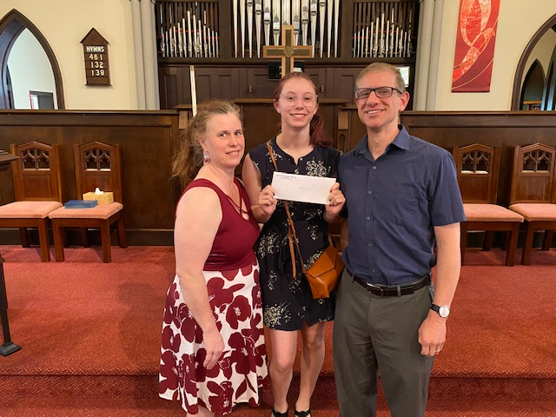

From the Special Gifts Committee

Baldwinsville’s Baker High School held it’s Moving Up Ceremony on Tuesday, June 9. As part of this annual ceremony, scholarships were awarded to some very deserving seniors. For the eighth year, the Special Gifts Committee awarded scholarships in memory of Arlene and Elizabeth Walter, firm believers in education, hard work and strong ethics. This year’s recipients were Rachel Bayer and Brennan Gruppe from Baldwinsville High School and Alana Adams from Westhill High School.

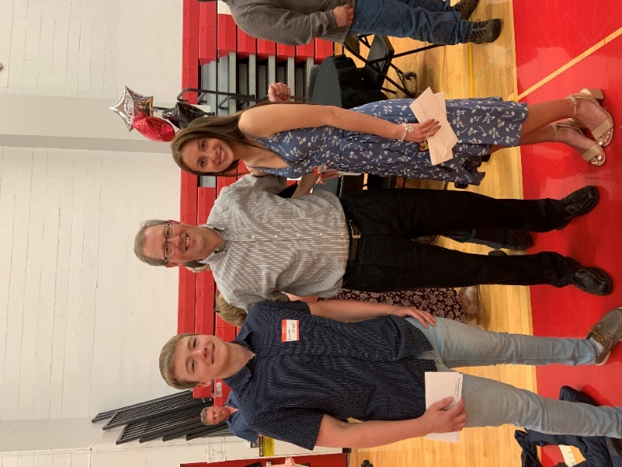

Brennan Gruppe, Andy Brussel and Rachel Bayer
Identity Statement

We are a loving family of God, following Christ by practicing our legacy of worship, education, and mission to neighbors.

Tricia, Alana and Shane Adams

Alana Adams
Alana is a 2022 graduate of Westhill High School. Alana is the daughter of Shane and Tricia Adams.

“I am so excited to be graduating! Highschool was a difficult, but worthwhile experience. I am planning on getting an apprenticeship at a bakery, so that a lot further in the future I will be able to open my own. This scholarship will hopefully be going to help fund that dream. Thank you so much!”-Alana Adams

Rachel Bayer

Rachel is a 2022 graduate of C.W. Baker High School.

During high school Rachel participated in many clubs including environmental club, volunteering through key club, and was the president of art club for her last 2 years of high school. She played lacrosse for 5 years for Baldwinsville, but stopped during her junior year. She continues to share her love for the sport by dedicating time to coaching Girl’s youth lacrosse for the past 3 years.

Rachel will be attending Suffolk University in Boston to study Marketing this Fall. Rachel is the daughter and stepdaughter to Bryan and Elizabeth Bayer.

Brennan Gruppe

Brennan is a 2022 graduate of C.W. Baker High School. He has been a very active Scout and received the honor of Eagle Scout last month.

Brennan will be attending college at SUNY Oswego on the fall to study electrical engineering. He is the son of Jamie and Megan Gruppe.

Do you have a graduate in your family? Send details to the Church Office and we will highlight them in the August Tidings!

Speaking of Scholarships…

The HB Strong Music Scholarship
was created to honor Heather Costello Bartman, daughter of Jon & Kathy Bowen. Students that receive this scholarship are of elementary age. It helps send kids to music camp or private lessons over the summer vacation. If you would like to contribute, please mail to:

Genesee Elementary Scholarship Program
Attn: Devon Roblee
244 W. Genesee Street
Auburn, NY 13021

Session Highlights

Attendance as of May 2022 is 857.
Live streaming subscribers are now up to 331.

Congregational Healthy Retreats
The first of the two workshops for the congregation held on June 11, was well attended and received. Rev. Mouser led the retreat and discussed how
congregations can become fractured and how the homeostasis can become disrupted by anxiety and conflict. He reiterated on the importance of
communication and the need for clear policies that can aid a congregation with daily operations.

The Welcoming Task Force for new and prospective candidates as our new pastor was discussed. What a new pastor and his/her family might need are important items to know. Those wishing to become a part of this important Task Force please contact Rev. Mouser.

Budget Report
The market, as we know, is ever-changing, but has increased church investments by approximately 3%. Expenses are less than $6,000 above 2021 and money from the Mission Initiatives Fund, earned last year, will be divided into half and
donated to the Bee-Full Program and Maureen’s Hope, a support program for cancer patients. Although a small amount, it was felt it would have the greatest impact for these two programs.

Buildings and Grounds
New mowers have been purchased and are doing well. Great thanks to the two Scouts that are mowing the church lawn for the summer. If children are on church grounds, it was recommended that the local police are made aware to ensure their safety. The church roof was inspected, some leaks were found, and
repairs shall begin soon. A bid is currently out to paint the church.

Nominating Committee
The MIF was signed by all and submitted to the Presbytery. This document essentially describes our church and our needs and will serve as a “job description to prospective pastors looking for a new opportunity.

July Birthdays

01 – Cathy Dickson 11 – Edie Hunter
02 – Kyle Pelcher 16 – Barry Bullis
03 – Sean Durkin 24 – Nancy Runyans
04 – Anna Demer 29 – Lynette Durkin
07 – James Pelcher 31 – Jeanne Le Porte

Add your or a loved one’s birthday or anniversary date to our list by contacting the church office.

July Anniversaries

05 – Kevin & Anthonia Todd
08 – Sean & Lynette Durkin
16 – Roger & Lynn Pohl (68th!)
21 – Brian & Cathy Dickson
25 – Barry & Alyce Bullis (52nd!)

The July Calendar

Sundays 10 am
Worship in the sanctuary

Mondays 6:30 p.m.
Bell practice in the Sanctuary

Sun. July 3
10 a.m. – Communion
2 p.m. – Communion at Buckley Landing

Mon. July 4
Happy 4th of July!
The Church Office will be closed

Fri., July 8 – 6:30 p.m.
Marriage of Katie Vicat & Dylan Laxton

Sat., July 9
Healthy Congregation Workshop
9 – 11 a.m. in the Sanctuary and Zoom

Mon., July 25
10 – 2 p.m. & 5-6 p.m.
Collection of Rummage Sale items begins

July 3 – Luke 10:1-11, 16-20
July 10 – Luke 10:25 - 37
July 17 – Luke 10:38-42
July 24 – Luke 11:1-13
July 31 – Luke 12:13-21

From the Deacon’s Desk

- We will continue to support the Bee Full program at Baker High school this summer- they are asking for Aldi's gift cards please contact Marty Pond at 315-440-0779 with any questions.
- Our 1st Community dinner for 2022 will be Thursday, September 1st- more information to follow but please mark your calendars.
- Our Ham dinner will be Saturday, October 8th. It will most likely be a drive-thru which is what other churches in our community are doing. Lots more information to come but as the saying goes "Many hands make light work". We hope many people will volunteer to help.
- Please remember to reach out to any Deacon if you know of anyone who needs a friendly phone call or maybe a "thinking of you"
card.

2022 Board of Deacons

Peg Brussel Pam Keckison Martha Stevens
Marge Calkins Matt McGivney Peggy Suddaby
Mark Chamberlin Marty Pond* Barb Winegard
Heidi Henderson Joanne Rodriguez
*Moderator

An Update from Troop 107
The month of May has been a lot of fun for Troop 107. We started the month by practicing fire building, lashing, and rope-tying abilities during scout meetings. We also went on our first campout to Scholtens this year. The Scholtens campsite is a private camp for Troop 107 that we recently refurbished with an improved exterior on the outhouse. Scouts that went got a first-hand experience of the dangers of stinging nettle on a small nature hike around the woods. No casualties have been reported. Before leaving, the sticks and muck under the bridge at the main campsite was cleaned out by Cam, Liam, Kevin, and Mr. Callahan. Water is able to flow far more freely now and it looks exponentially nicer.

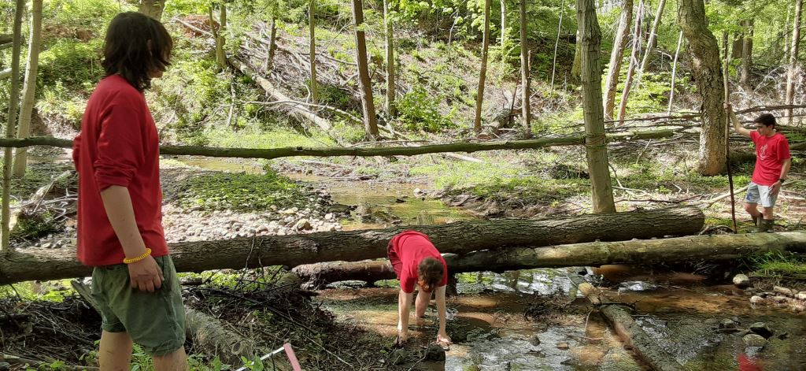
The following weekend on Friday the 20th and Saturday the 21st, a variety of scouts showed up at the main pavilion in Van Buren Park to help set up and run an annual 5k race in remembrance of US veteran, Kyle Schneider. The event is run by the Corporal Kyle Schneider Foundation and is their primary fundraiser. They are a huge supporter of local scouting, so it was nice to give back to them by volunteering. Some scouts and family members even ran in the race to show their support and donate towards the organization.
May is a time to remember loved ones lost to the cruel conditions of war. A way that many local scouting groups do this is with an annual event in the area that took place where multiple Troops and Cub Scout Dens showed up to assist the American Legion with placing US flags on the graves of Veterans in the Riverside & St. Mary’s Cemeteries on the 19th. All the veterans buried in these cemeteries were honored with their own flag and
were shown the utmost respect from scouts. Later that same month, on May 30th, there was a Memorial Day Parade in the village of Baldwinsville that Troop 107 attended. It was a great turnout and it was an honor to represent Scouts BSA.

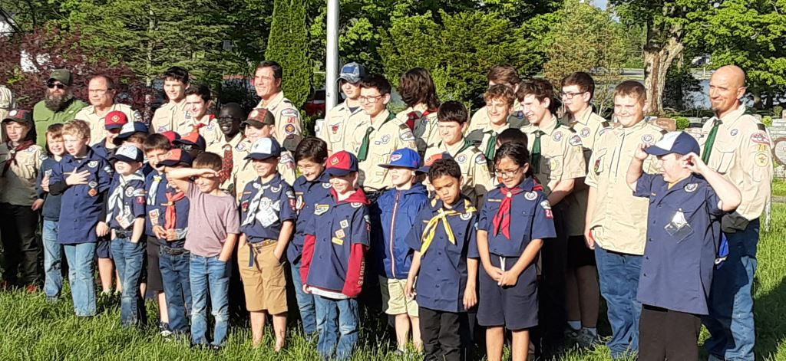

One of our scouts, Brennan Gruppe, recently proved his perseverance and leadership abilities, becoming an Eagle Scout. The Eagle Ceremony was held Monday May 23rd at the church where Brennan accepted the honorable title as well as the responsibilities that come with it. The Eagle Scout rank is the most prestigious rank, awarded to a scout after they have taken on a variety of tasks in order to prove their strength as a scout and future leader of America. We are very proud of Brennan and all that he's accomplished; we know he will go on to do amazing things!
As we go into June, Scouts are preparing for summer camp. It is a treasured annual tradition that we are glad to continue. Although no meetings will happen over the summer, newsletters will continue to update. We wish all our high schoolers good luck on their finals and are also wishing all of you an amazing start to the summer!
-Cam Padalino

Remember in Your Prayers
& Correspondence,

since our last newsletter

❤ Health Challenges
Barry Bullis
Nancy Dobbins

~ ~ ~ ~ ~

Generally, names remain on the prayer list for
one month. Please let the church office know
if you wish otherwise.

Season of Pentecost
Worship Outlines

July 3 Unexpected Prophets

2 Kings 5:1-14 Psalm 30 Galatians 6:1-16 Luke 10:1-11, 16-20
Help comes to Naaman from an unexpected source – a young Israelite serving girl. Naaman hopes for a dramatic healing of his leprosy. However, God’s healing and restoration come through unforeseen prophets. As the other readings affirm, God’s presence is revealed through perseverance and faithful witness.
Within the Christian tradition, there are many examples of people who have worked alone or joined with others to spread the good news of God’s reign of justice and peace – to make a difference for good. We are sent to spread the good news of God’s reign of justice and peace to those we meet every day. What supplies do we need for our journey and ministry?

July 10 Compassionate Neighbors

Amos 7:7-17 Psalm 82 Colossians 1:1-14 Luke 10:25-37
This week’s readings invite us to consider how love and compassion are the essences of living faithfully. They call us to shape our lives according to God’s justice and mercy, striving for relationships that enable community. God’s word has ultimate authority and responding to God’s call for justice and compassion is everything.
We are called to live into the reign of God, where every human being is treated with love and justice. As com-passionate disciples, we love God with all our hearts and our neighbors as ourselves. What acts of justice and kindness – given and received – have accompanied your faith journey? In what ways do members of your church strive for relationships that enable community to flourish?

July 17 Faithful Listeners

Amos 8:1-12 Psalm 52 Colossians 1:15-28 Luke 10:38-42
The call to take up the role of discipleship encompasses a call to ground our daily living in the word of God. Each day, there are opportunities to hear and follow God’s word, if only we pause

and listen. The action of faithful discipleship is informed by reflection on Christ and the way of God’s realm.
What priorities, ways of doing things and fears do we have that hinder our response to the gracious call of Christ in our lives? What in our lives might we need to let go as we travel the way of discipleship?

July 24 Prayerful Disciples

Hosea 1:2-10 Psalm 85 Colossians 2:6-19 Luke 11:1-13
Prayer is at the heart of discipleship. Prayer is at the heart of our relationship with God. The readings for today lift up God’s nature of love and compassion; they assure us of God’s readiness to hear and attend to our prayers. As we pray, we know God more fully, and as we know God more fully we pray confidently and with persistence.
Our understanding of the nature of God informs our life of prayer. We believe that God is loving, compassionate, reliable, and responsive, as these passages assert. How then shall we pray?

The Rummage Sale is scheduled for August 5 & 6! As in previous years, we will fill the Fellowship Hall and tents outside with treasures for sale. Clean, useable items may be brought to the Education Center beginning Monday, July 25. We will not have room to store items before this date.

Hopefully we will have another successful sale this year. As usual, we do NOT accept televisions, computer and most other electronic items.

Volunteers are needed to help sort items from July 25 until August 4 and volunteers to work at the sale on August 5 & 6. If interested, please call Kathy Bowen at 315-638-8749.

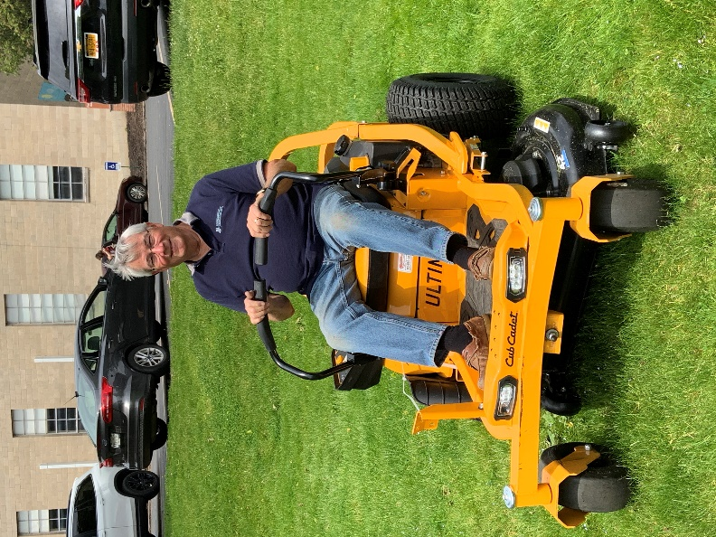
Rush is testing out the new lawnmower
purchased by the Special Gifts Committee.
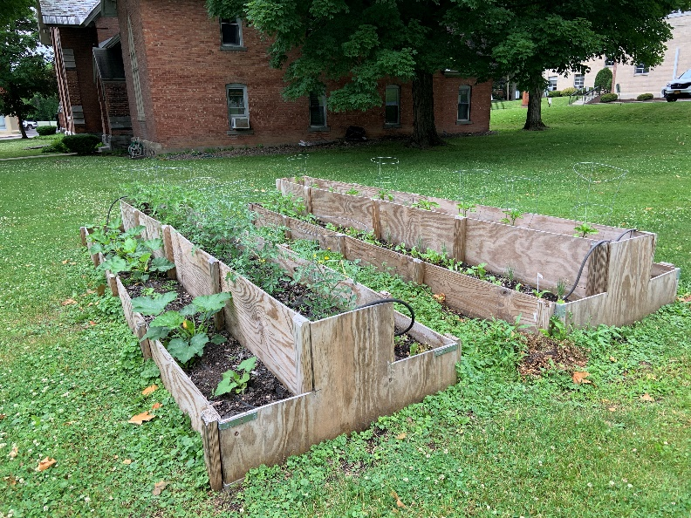

The Buildings and Grounds Committee has been hard at work preparing for the summer season. Bobbi Roloff has a lot of vegetables coming up in our Garden of Eat’n. Lee Calkins brought his tractor down to help the crew spread freshly delivered mulch. As always, many hands make light work!

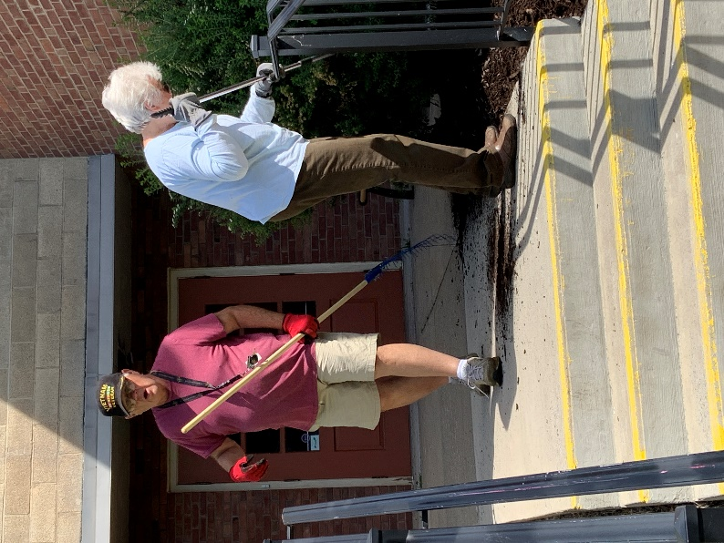

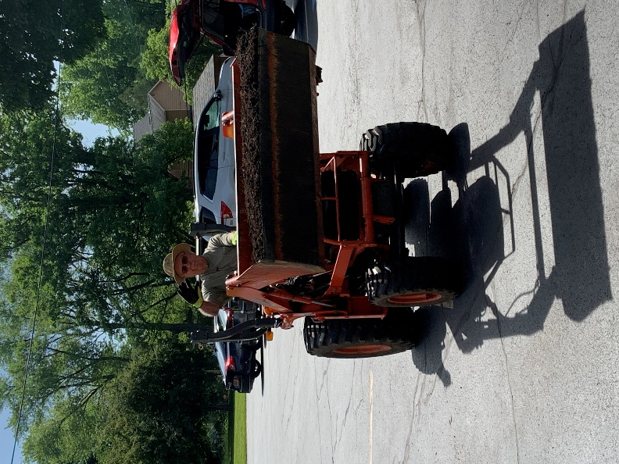

Generous Donations

The Presbytery gave each church some Mission money and we received $1,237.61!

At last week's Session meeting it was voted to divide the money between two local organizations:

1. Bee Full Food Pantry- This money will be used to supply more gift cards to families in need this summer.

2. Maureen's Hope Foundation-The mission of Maureen’s Hope Foundation is to offer practical support and assistance to people facing the challenges of a cancer diagnosis or other life altering disease.

An Interesting Coincidence!

A couple weeks ago the handbell ringers played "Wonderful Words of Life" by Philip Bliss. Near the time we were practicing this music I was reading a travel brochure from Bradford County in Pennsylvania. One of the featured sights to visit is a gospel music museum named for Philip Bliss. In reading further, I learned that he wrote over 300 gospel songs and that set me on a course to find more of his music. I will be looking for more of his music to offer in worship. Incidentally, P.P. Bliss wrote the tune for "It Is Well With My Soul". Once again, a chance to learn something new--by coincidence.
Rheta Jenks,
Music Coordinator

From the Mailbox

Thank you so much for your generous donation for Bee-Full Food Pantry. Baker families ae forever grateful for your kindness and support. Please know that your assistance is greatly appreciated.
-Bee-Full

May we think of freedom, not as the right to do as we please, but as the opportunity to do what is right.

-Peter Marshall

Church Office – Education Center 64 Oswego St.

Interim Pastor-----------Rev. Dr. Carson O. Mouser
Administrative Assistant-------------Elizabeth Bayer
Clerk of Session---------------------Stephanie Stine
Deacon Moderator------------------------Marty Pond
Director of Music & Choir----------------Rheta Jenks
Organist ---------------------------------Lee Johnston
Nursery School Director------------Jessica Newcomb

