June 2022 First Presbyterian Church, Baldwinsville, NY accessible facilities

TIDINGS
church office hours Monday – Friday 9 am – 2 pm
church office phone 315-635-9964 nursery school 315-635-7391 fax 315-638-4792 website presbville.com

,,,,

published in the Church Office editor/admin - admin@presbville.com 10:00 am Sunday Worship

Walking with the Apostles: Planting Churches

Come walk with the apostles as they plant churches and spread the gospel from Jerusalem to the ends of the earth for three five-week segments.

We begin our walk with the apostles 11 am Mondays in-person and Wednesdays at 7 pm via Zoom starting Wednesday, June 8, and ending the first five-week series Wednesday July 6. The second five-week segment will begin Monday July 18 and end Wednesday Aug.17. The third five-week segment will start Monday Aug. 29 and will end Wednesday Sept. 28.

This walk with the apostles will cover the entire book of Acts of the Apostles and will touch on topics and issues followers of Christ will continue to talk about throughout the next 21 centuries. John Calvin, Swiss theologian and founder of Presbyterian theology and polity often pointed the reformed churches back to the early days of the Christian church to find not only how the church began, but what the early Christians were thinking about God, Jesus Christ and the gospel, because the Medieval Western Christian Church had strayed far off the path the first created by Jesus the Christ and the apostles.

Now, as Frist Presbyterian embarks upon the journey of calling a new installed pastor to walk with you into your future, it seems the best time to retrace the steps and conversations and struggles and challenges the apostles experienced as they set out to teach what Jesus taught them, baptizing new believers in the name of the Father, the Son, and the Holy Spirit from Jerusalem to the ends of the earth.

If you want to join this summer long walk with the apostles, please let me know because we will be using a study guide created by Mark Copeland and Kevin Scott with some changes I have made. The study guide will be like a great guidebook, leading us to see what is interesting and important, but giving us the space to think for ourselves.

I look forward to leading you all on this walk, so grab your hiking stick, bibles, and study guide, plus some delicious snacks and join me in person or via Zoom.

Peace,
Pastor Carson

Identity Statement

We are a loving family of God, following Christ by practicing our legacy of worship, education,
and mission to neighbors.

Session Highlights

A Congregational Meeting was held May 8, 2022 to elect a Pastor Nominating Committee (PNC). Six nominees were presented and all were approved to serve. A second committee shall be developed that will serve to both welcome a new pastor and his/her family but also provide information that will help them settle into the area such as; area schools, libraries, healthcare access, hospitals and grocery and personal shopping areas.

In- Person Attendance for April totaled 197. YTD: 657

Live streaming subscribers totaled 29 with view of 93. Total YTD: 220 viewers.

PASTOR’S REPORT
The Healthy Congregation Workshops are scheduled for June 11th and July 9th, both in the Fellowship Hall and starting from 9:00 a.m. until 11:00 a.m. Policies and procedures are currently under review to update the current Church Handbook.

STEWARDSHIP CAMPAIGN
Planning for the annual Stewardship Campaign is underway! As part of stewardship this year Session agreed to add a “Mission Committee” that will assist in the planning. Letters to the congregation announcing the campaign is forthcoming and should go out sometime in the early fall.

BUILDING AND GROUNDS
Three areas of focus were recommended for the church grounds over the next few months; painting the outside of the church, tree trimming, and the purchase of two lawn mowers to replace those that have had a lot of wear and tear. Session approved the purchase of both a riding lawn mower and push mower to assist with this project this season. We are actively looking for one or two people that would like to possibly job-share this duty over the summer months. Students are encouraged to apply if interested.

COMMUNICATIONS
Copies of the book “Healthy Disclosure: Solving Communication Quandaries in Congregations” shall be purchased with education to follow on methods, tactics, and ideas to share with members of the congregation.

COVID UPDATE
With a reported upswing in cases of COVID the last few weeks we are asking for everyone to proceed with caution and awareness as this pandemic continues. We recommend that if you don’t feel comfortable attending an event of any kind, or if you are feeling unwell, to please remain at home until you’re feeling better, and/or CDC recommendations change and the church can make adjustments for these changes.

2022 Session Elders

Tricia Adams Harry Boak Andy Brussel
Jamie Gruppe Victor Jenkins Jeanne Le Porte

Rush Pond Stephanie Stine*

*Clerk

Thank you!…
To all of the volunteers who showed up on April 30 to help clean up our grounds and get it prepared for our Spring and Summer seasons. Everything is in full bloom now and the grounds look wonderful!

Quarterly Statements

Quarterly contribution statements were sent out via email. If you did contribute, and did not get a statement emailed to you, please send an email to giving@presbville.com, or call the church office at 315-635-9964.

June Healthy
Congregation Workshop

The first Healthy Congregation Workshop is 9 a.m. to 11 am, Saturday, June 11 in the Fellowship Hall and is open to all Ruling Elders, Deacons, staff, and members of the congregation.
This is the first of two workshops that will happen in the first two months of summer. These workshops are designed to begin a conversation about what it means to be a healthy congregation where boundaries are established and respected by everyone, where anxiety is not high and where leaders become the immune response to anxiety as well as taking those positive aspects of the congregation’s past into the future, being truth-tellers about the past, and how patterns of behavior from the past do not have to continue to disrupt the congregation’s future. The workshops do not repeat the same material, so it is important to attend both workshops to benefit from them.
The first Healthy Congregation Workshop will focus on the congregation as a whole community with boundaries that maintain the community’s wholeness using Genesis 1:2:4 and Exodus 20:1-17 as examples of boundaries being set to create a community that is sustainable for every member of the community. Additionally, we will look at two examples of how leaders in a congregation handle anxiety and we will look at case studies of how two congregations handled traumatic boundary transgressions differently and the different outcome each congregation experienced and continue to experience.
The second workshop addresses trauma and conflict by understanding that conflict is not about the content of disagreement but is about anxiety, and managing conflict is about self-differentiation as the response to the emotional drivers of conflict and understanding the role of communication in either increasing conflict or effectively managing conflict.
Each of the workshops may be accessed through Zoom, if we have participants who want to attend this way, those folks will need to let me know by June 7, so I can send a link. I pray each of you will choose to participate in the two monthly workshops, since they will build upon one another and will impact and influence the congregation’s future and the relationship with the next installed pastor. See you Saturday, June 11, 9 a.m. to
11 a.m.

Luncheon Success!
The Special Gifts Committee sponsored a Baked Potato Lunch on Sunday, May 8 after worship. The occasion was part of Wills Emphasis Sunday at the Church. It was also a nice to way celebrate “Mom” on Mother’s Day!

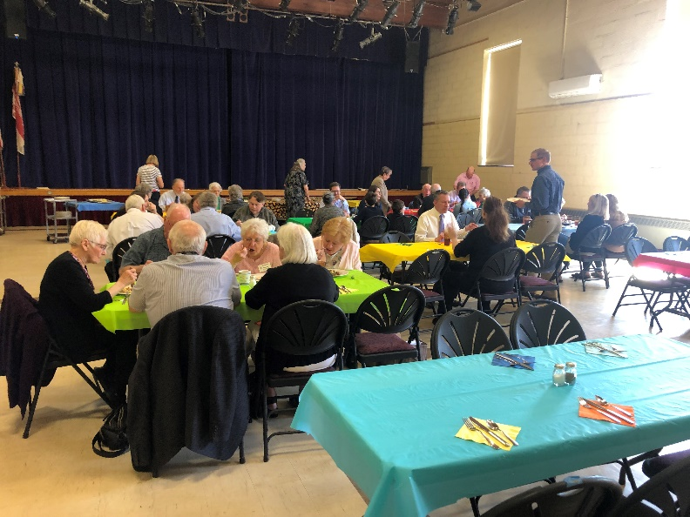
June Birthdays

01 – Jamie Gruppe
03 – Peg Brussel 19 – Marla Barton
09 – Connie Chapman 19 – Amy Miller
11 – Lee Calkins 21 – Hannah McGivney
14 – Tom Rogers 24 – Kelly Pelcher
18 – Doug Crawford 25 – Harry Boak
18 – Josephine Pennock 29 – Fred Miller (Virginia)

June Anniversaries

20 – Chuck & Edie Hunter
28 – Al & Janice Jenner

Add your or a loved one’s birthday or anniversary date to our list by contacting the church office.

Season of Pentecost

June 5 - A Spirit Powered Faith
- Pentecost Sunday

Acts 2:1–21 Psalm 104:24–34, 35b Romans 8:14–17 John 14:8–17, 25–27

Pentecost Sunday is a day to celebrate the breath and fire of the Spirit that lives and moves and acts among God’s people. This Spirit of liberation and freedom poses an inevitable challenge to a spirit of domination so present in the world. The Spirit gives us a new identity, one infused by God’s desire for the world.

Pentecost Sunday also celebrates the animating and sustaining presence of God’s Spirit within the church. Perhaps it is for this reason we celebrate the “birthday of the Christian church” on this day. The Spirit gives the church its mission and the power to undertake it. As you look into the future, what mission is the Spirit giving to you and your church?

June 12 Wisdom Calls – Trinity Sunday

Proverbs 8:1–4, 22–31 Psalm 8 Romans 5:1–5 John 16:12–15
On this Trinity Sunday, the texts remind us that God dwells in community as Creator, Wisdom, and Spirit. How then do we live as people who are in community with all Creation?
This Trinity Sunday, we celebrate the faith and hope that the Creator’s love pours into our lives by Christ and the Holy Spirit. We are invited to join with Wisdom in a dance of delight and celebration of God’s activity and to hear Wisdom’s prophetic call to revere all that God has created. Where is the dynamic action of God noticeable in our lives? What is Wisdom calling us to care for this week?

June 19 Deep Down Questions

1 Kings 19:1–4, (5–7), 8–15a Psalm 42 and 43 Galatians 3:23–29 Luke 8:26–39

This week’s readings invite us to turn our whole selves – body, mind, and spirit – toward God, who envelops us in grace. God nourishes and sustains us and reaches out to us in the depths of

our despair or aloneness. There are challenges in being faithful; God delights in each one of us and supports us as we journey in God’s presence.

There are times when life overwhelms us, and we despair. What questions come to us in such “deep down” moments? God nourishes and sustains us when we allow quiet moments in God’s presence to heal and restore us. God sends us back to continue our discipleship in our daily lives. In God’s love, we find truth, promise, and hope.

June 26 Take Up the Story

2 Kings 2:1-2, 6-14 Psalm 77:1-2,11-20 Galatians 5:1,13-25 Luke 9:51-62

We receive stories, traditions, and visions of our faith and weave them into the fabric of our own lives. In turn, we pass these stories, traditions, and visions along to others. We pick up and hand on the mantle God gives, as we journey under the Spirit’s guidance.

We pick up and hand on the mantle God gives, as we journey under the Spirit’s guidance. There are many kinds of leadership and many opportunities to serve as followers. Like Elisha, we follow others from whom we have learned about God. Who are the faith ancestors who have helped you understand the Christian faith? By our baptism, we are called to pick up the mantle of discipleship. Where do you experience the challenge and cost of responding to God’s call? Where do you experience the promise?

Wear RED on Sunday, June 5, in celebration of Pentecost Sunday!

From the
Deacon’s Desk

- We will continue to support BeeFull during the summer months- they will be sending Aldi gift cards to families during the summer.
Donations of Aldi gift cards or money are greatly appreciated! The BeeFull group has sent the Deacons many Thank you notes expressing their appreciation.

- During the summer months we don't want to forget our shut-ins and people who we do not see in church. If you know someone we should reach out to, please let Marty Pond know at 315-440-0779

2022 Board of Deacons

Peg Brussel Pam Keckison Martha Stevens
Marge Calkins Matt McGivney Peggy Suddaby
Mark Chamberlin Marty Pond* Barb Winegard
Heidi Henderson Joanne Rodriquez
*Moderator

Remember in Your Prayers
& Correspondence,

since our last newsletter

❤ Health Challenges
Barry Bullis
Nancy Dobbins

~ ~ ~ ~ ~

Generally, names remain on the prayer list for
one month. Please let the church office know
if you wish otherwise.

June 5 – John 14:8-17
June 12 – John 16:12-15
June 19 – Luke 8:26-39
June 26 – Luke 9:51-62

What is on the Calendar?

Sundays 10 am
Worship in the sanctuary

Mondays 7 pm
6:30 p.m. – Bell practice in the Sanctuary
7 p.m. - Boy Scout Troop 107
Fellowship Hall

~ ~ ~

Sun., June 5
Day of Pentecost & Communion – 10 a.m.
Wear Red! Coffee Hour to follow worship.
Communion at Buckley Landing

Mon. June 6
Music & Worship, 1:00, Media Center
Girl Scout Troop #60735

Weds., June 8
Girl Scout Troop 60867, 6:00

Sat. June 11
Healthy Congregation Workshop
Fellowship Hall, 9-11 a.m.

Tues., June 14
Session, Media Center, 7 p.m.

Sun., June 19
Happy Father’s Day!

Mon. June 20
Girl Scout Troop #60735, 5:45 p.m.

Tues., June 21
Deacons, Media Center, 7 p.m.

In the Mail

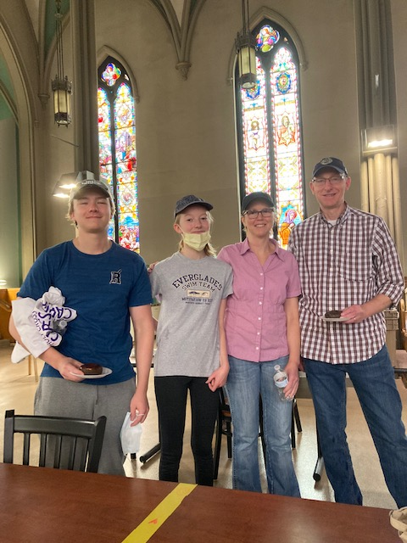
A big Thank You to members of our congregation for your support and offers of help while Mic was in the hospital and during the days that followed - phone calls, offers to help, cards, visits and food. A very special thank you to Barb Winegard and to all who made cookies for the memorial gathering at Beaver Lake Nature Center. We appreciate all who came to his service and to all who shared their stories with us and enjoyed the music provided by Marylyn's cousin, Marilyn Fuller and friends.

-Thank you from Marylyn Jenkins and Family

Thank you for your generous donation towards Bee-Full Food Pantry! Your kindness is greatly appreciated. Bee-Full is feeding over thirty families this year and it is because of people like you!
Thank you,
Bee-Full

First Presbyterian Church:

On behalf of all of those benefited, I would like to thank you for your generous support of the meal program here at the Samaritan Center! Your donation helps us provide a nutritious, well-prepared and dignified meal daily, without conditions to men, women and children.

Your involvement makes it possible to offer a place of safety, hope and opportunity to individuals and families struggling with hunger and poverty. It could not happen without you.

I can not fully express the difference you make in the lives of those we serve through your support and generosity. I can only offer my sincerest thanks and gratitude for your faith in us and the work we do to help those in need.

With deepest appreciation,
Mary Beth Frey
Executive Director, Samaritan Center

The Gruppe family stops for a picture after volunteering
for a morning shift at The Samaritan Center

Garden of Eat’n

Bobbi Roloff is continuing her great work with our vegetable garden this year to help support the local Food Pantry. If you would like to join in the fun of planting, caring for and harvesting our vegetables, please contact the church office.

Scouting News

This past month was very eventful for Troop 107. The month of April was started with the continuation of the Eagle rank required Communication merit badge, led by fellow scout Kevin Callahan. The scouts quickly finished this merit badge after only a few weeks of improving their leadership skills and learning how communication plays into their daily lives.

April doesn’t only have showers that bring May flowers, it also has Spring Break! Over the break, many scouts volunteered their time to build and assemble beds for children (ages 3-17) in need. They ended up constructing 26 beds that have been donated to less fortunate kids. It was a small amount of time out of their day, but I'm sure it made a huge difference for the children who received the beds.

Towards the end of April, some scouts decided to join David Padalino and camp out in tents on his private campsite that has been dubbed Camp David. The scouts and adults decided to sleep outside and in their tents overnight. It was a bit muddy, but those who went persevered and even took a few small hikes around the area. They even saw an animal farm where they got to interact with and pet some of the livestock. In addition to the hikes, everyone helped pick up sticks for Earth Day that they used for a bonfire. Scouts also learned how to make Hobo stoves out of coffee cans, using them to cook their meals. It was an adventurous and fun learning experience for everyone who went.

To end the month of April, Troop 107 decided to give back to our community, specifically the church, by participating in the Spring Church Cleanup. Scouts raked leaves and debris as well as helped prepare the property for summer. The church does so much for our Troop that it only feels right to give back by helping out whenever they need us.
-Cam Padalino, Troop Scribe

Nursery School News

It’s hard to believe another school year has come to an end. In just 10 short months these preschoolers grow and change so much! They come in looking so little and leave us ready to take on Kindergarten.

Thank you to all of you who came out to attend the craft fair. This was another great fundraising opportunity for the nursery school. Have a
wonderful summer and we look forward to our return to school in September.
- Jessica Newcomb, Director, PNS

The Rummage Sale is scheduled for August 5 & 6! As in previous years, we will fill the Fellowship Hall and tents outside with treasures for sale. Clean, useable items may be brought to the Education Center beginning Sunday, July 24. We will not have room to store items before this date.

Hopefully we will have another successful sale this year. As usual, we do NOT accept televisions, computer and most other electronic items.

DAD:

A son’s first hero.
A daughter’s first love.
Happy Father’s Day!

On May 23 the Gruppe’s celebrated Brennan’s achievement of becoming an Eagle Scout. Quinn, who is also an Eagle Scout was master of ceremonies. We are very proud of Brennan and thankful for this caring church that has sponsored Troop 107 for so long.

-Jamie and Megan Gruppe

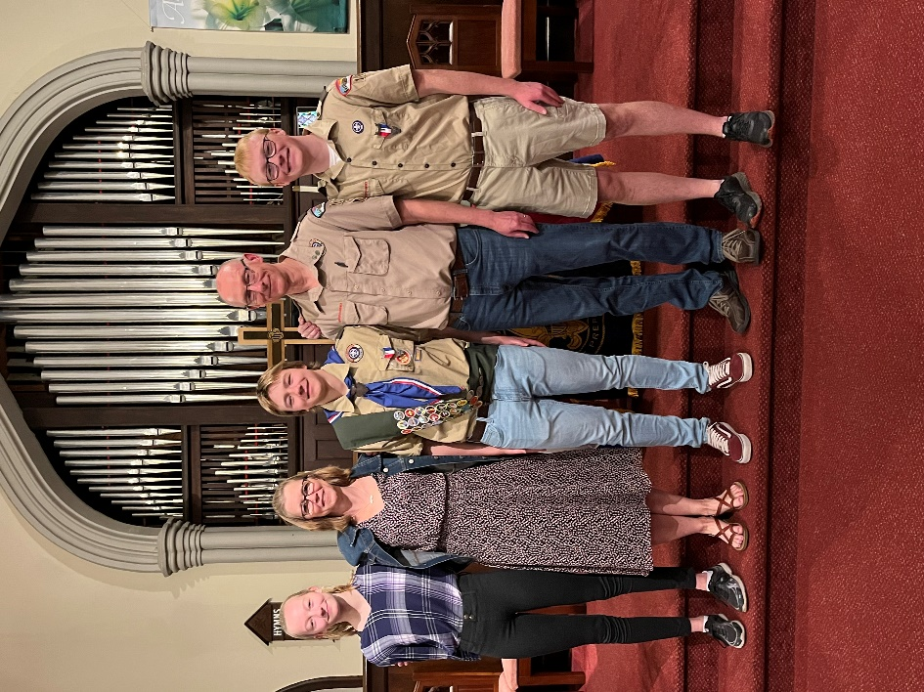

If you have a bike that you would like to donate, please call Linda McMahon at 315-638-2461 and she and her husband, Joe, will make arrangements to pick it up from your home.

Grace Episcopal Church is hosting their 55th Annual Chicken BBQ on Saturday, June 4, from noon until sold out. The church is located at 110 Oswego Street (Rte. 48), in Baldwinsville. The cost is $12 for a half-chicken meal which includes salt potatoes, baked beans, a roll with butter and dessert.

