November 2022 First Presbyterian Church, Baldwinsville, NY accessible facilities

TIDINGS
church office hours Monday – Friday 9 am – 2 pm
church office phone 315-635-9964 nursery school 315-635-7391 fax 315-638-4792 website presbville.com

,,,,

published in the Church Office editor/admin - admin@presbville.com 10:00 am Sunday Worship

“Gratitude is the Radical Reaction to Life”

“Gratitude,” Thomas Merton has said, “takes nothing for granted, is never unresponsive, and is constantly awakening to new wonder and to praise the goodness of God.”

Gratitude and generosity remind us that we give thanks and praise to God when we pay close attention to Jesus’ call, “if any want to become my followers, let them deny themselves and take up their cross and follow me.”

This is a call to deny that which we think of and cling to as ours, so we might, like Christ, grab hold of the ministry God is calling each of us to do. A ministry that is just a small piece of God’s vision for the world that allows us to focus on the freedom and the joy of discipleship and the adventure of passionately giving our lives, resources, and energy to the specific ministry Christ calls us to do.
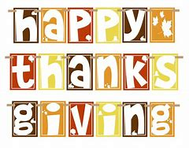
Yet, gratitude is also a response to grace as Henri Nouwen wrote many years ago. Indeed, Nouwen connected gratitude with the compassionate life because “a compassionate life is a grateful life” and as Nouwen taught us, all “actions born out of gratefulness are not compulsive but free, not somber, but joyful, not fanatical but liberating. When gratitude is the source of our actions, our giving becomes receiving and those to whom we minister become our ministers.”

In addition, gratitude compels us to recognize all the blessings we receive and take none of them for granted, but treat each as a gift of love so we might see beyond the gift to the person giving us the gift whether it is a dinner prepared by a friend, a husband or wife who willingly washes the dinner dishes, a child who takes the garbage out, a note from a friend, a call from a family member, or any number of the small gifts we receive each day and week. Our awareness of the gift giver leads to the awareness of the love involved in such everyday gifts and may even give us a glimpse of the wonder of friends and family and in these intimate moments you may realize, if just for a moment, that you are part of something larger than yourself or your surroundings, sensing you are intertwined in God’s indescribable generosity creating within you the recognition that your whole life is a gift. A gift given by God which encompasses everything in the world around us from every plant, animal, water, rock, and air; that every breath we draw is gift of God’s love; that every moment of our existence is a grace because it brings with it, taught Merton, immense graces from God which we are able to receive and respond with gratitude.

Gratitude is the appropriate response to God’s love and blessing of life. John Calvin wrote about it this way, “Thankfulness is the chief exercise of godliness in which we ought to engage during the whole of life because gratitude is the heart of the Christian life that is a response to seeing life as a gift from God and realizing that our lives belong to God. God is the gift giver we are the thanks-givers.”

During this Stewardship season when we are pondering our pledges and our service to the mission and ministries of First Presbyterian Church that Christ is calling us to do may gratitude guide our decisions and commitments.

Peace,

Pastor Carson

Highlights from Session

Attendance for services is up to 1,427 members through September of this year.

Pastor’s Report
Rev. Mouser will meet with members of the Floral Committee to discuss the “Hanging of the Greens” for 2022. Christmas worship services are being finalized, and there was a meeting with a representative of Interfaith Works to learn more
about their “One-to-One Program. More information on this program shall be discussed at the October 23rd services. A new Bible Study will begin in a few weeks. More to follow on specific dates and times. Rev. Mouser shall be on vacation from November 13 through the 26th.

Budget and Finance
Special Gifts transferred $40,000 to the general budget and we are happy to report that with an YTD pledge of $69,000, we have received $99,000 in pledges for the year. It is such a blessing during these challenging financial times that all of you
are steadfast in supporting the mission of the First Presbyterian Church.

The Annual Stewardship Campaign for 2023
The Stewardship Campaign will begin sending letters by the end of October. Hopefully all pledges for 2023 shall be received by November 20th. Karen Chamis shall be discussing the meaning of stewardship in her sermon on October 30th. Hope everyone will come to hear her words. We hope to have everything finished by the 4th of December so we can report our financial situation to the Congregation on December 11, 2022.

The Search for a New Pastor continues as an interview with a fourth candidate was held very recently. All was very positive and efforts shall continue.

Healthy Disclosure Reference Text
Hopefully everyone has been taking the time to read this book on effective communications within a congregation. There is a chart at the end of the book that outlines more specifically formal lines of communication that we might use as guidance. Rev. Mouser will be meeting with those in the congregation involved with the new Communications Committee to give us some ideas that are similar to the Presbyterian Church in Skaneateles for us to consider.
2022 Session Elders

Tricia Adams Harry Boak Andy Brussel
Jamie Gruppe Victor Jenkins Jeanne Le Porte

Rush Pond Stephanie Stine*

*Clerk

November
Birthdays

02 – Doug Russell 21 – Cathy Mocyk
06 – Freida Mason 22 – Suzanne Mills
07 – David Sandwick 23 – Wanda Wachob
08 – Marge Calkins 24 – Patrick Smith
09 – Helen Roe 28 – Lori Crawford
17 – Charlotte Pennock 29 – Andy Brussel
19 – Quinn Gruppe 29 – Sage Robbins
30 – Bob Brussel
November Anniversaries

19 – Rush & Marty Pond

Add your or a loved one’s birthday or anniversary date to our list by contacting the church office.

“Come Hang the Greens”

Plan to take part in the traditional “Hanging of the Greens” at once following worship November 20. This annual event is a time for preparing the church for Advent and Christmas seasons and a time for fellowship. Many hands will make the work light and many people create a time of joy in anticipation of the coming of Christ. Also, we will be supplying refreshments, so please plan to take part.

Floral Committee
Seeks Members

The Floral Committee is seeking more people to help with its work of supplying flower arrangements each week for the sanctuary and decorating the sanctuary for each season of the church year, including adding paraments, banners, and other visual art to draw people to worship.

If you are interested in helping supply visual artistry to complement the musical prayers, sung prayers, and spoken prayers of worship that offers praise and thanksgiving to God, please contact Pastor Carson, or call or email Elizabeth in the Church Office.

From the Deacon’s Desk

- See the article about the H.E.L.P. project on the following page.
- The Deacons will resume passing the offering plates as we did pre-Covid. It will be nice to have this ritual back as part of our worship service.
- Bee-Full & Baldwinsville Food Pantry- we will be collecting food for both with the idea that members might have something they wish to donate that really is not appropriate but would be used by the food pantry-for example big, bulk food items. Please put all donations in the red wagon in front of the church or in the Bee-Full boxes in the sanctuary or church office. A member of the Deacons will sort the food and make the delivery. Thanks so much for your continued support.
- We will be doing our Angel Tree this year during Advent. What a wonderful way to celebrate the joy of Christmas by giving Christmas presents to those who would otherwise not receive Christmas gifts. We will be purchasing gifts for PEACE & Bee-Full families.

2022 Board of Deacons

Peg Brussel Pam Keckison Martha Stevens
Marge Calkins Matt McGivney Peggy Suddaby
Mark Chamberlin Marty Pond* Barb Winegard
Heidi Henderson Joanne Rodriguez
*Moderator

The November Calendar

Sundays 10 am
Worship in the sanctuary

Mondays
11:00 a.m. – The Epistle to the Romans Bible Study in the Media Center (every Mon. this month)
6:30 p.m. - Bell practice in the Sanctuary
7-9:00 p.m. - Scouts in the Fellowship Hall

Wednesdays
7:00 p.m. – The Epistle to the Romans Bible Study, via Zoom (every Weds. this month)

Thurs., Nov. 3
4:00 – 5:30 – Community Dinner, See article in this issue for more details.

Sun., Nov. 6
10:00 a.m. – Worship and Communion
11:00 a.m. – Buildings & Grounds Clean-Up
2:00 p.m. – Ecumenical Worship at Buckley Landing

Mon., Nov. 7
10:00 a.m. – Music & Worship Committee in the Media Center
5:45 p.m. – Girl Scout Troop 60735

Tues., Nov. 8
7:00 p.m. – Session, Media Center

Weds., Nov. 9
2:00 – Parkinson’s Support Group, Media Ctr.

Fri., Nov. 11
The Church Office is closed in recognition of Veterans Day

Tues., Nov. 15
7:00 p.m. – Deacons, Media Center

Sun., Nov. 20
11:00 a.m. – “Hanging of the Greens”

Thurs., Nov. 24
Happy Thanksgiving Day
The Church Office is closed

Fri., Nov. 25
The Church Office is closed
Nov. 6 – Luke 20:27-38
Nov. 13 – Luke 21:5-19
Nov. 20 – Luke 23:33-43
Nov. 27 – Matt 24:36-44

Remember in Your Prayers
& Correspondence,

since our last newsletter

❤ Health Challenges
Barry Bullis
Nancy Dobbins
Anthonia Todd

❤ recovering
Mimi Dundon – temporary address
Syracuse Home, Rehabilitation Unit,
7740 Meigs Road, Room 308,
Baldwinsville, NY 13027

Lillian Olsen
Stephanie Stine

~ ~ ~ ~ ~

Generally, names remain on the prayer list for
one month. Please let the church office know
if you wish otherwise.

Book Club!

﻿We continue to meet the first Tuesday of each month at 10 a.m. in the Media Room. All are welcome on November 1st!

For October, we are reading “One Summer”, by Bill Bryson. Mr. Bryson was born and raised in Des Moines, Iowa. He currently resides in England, with his wife (who is English) and children. He has written over 20 books.

“One Summer” views American life thru the lens of the year 1927. Bill recounts events and their origins and future implications. For instance, the 1920’s were glory days for newspapers and magazines, more published than any other time. Also, the tabloid was born that decade and we know continues to survive. The Lindley flight and his multiple competitors are closely chronicled.

H.E.L.P Project

Household
Essentials for
Living
Pantry

The Baldwinsville Volunteer Center has established the H.E.L.P. Project to assist our local food pantry in obtaining daily basic household supplies such as personal care items, paper items, cleaning products and baby items. The Deacons voted to support this project by collecting personal care items in the month of November. Personal care items include: 2/1 shampoo/conditioner, toothpaste, toothbrushes, bar soap, body wash, razors, shaving cream, deodorant, lotion and hand soap. Watch for special boxes in the Sanctuary and in the Church Office. Please help support this local project!

Community Dinner
The next free Community Dinner is only a few days away on Thursday, Nov 3. It will be a sit-down meal with take-outs available. We have plenty of volunteers signed up to cook, serve and clean up. If you’re not one of those people, please consider joining us for Pork Roast, Mashed Potatoes & Gravy, Cheesy Spinach Bake, Applesauce, Rolls & Butter and Assorted Desserts. (Of course, volunteers are also able to take a break and sit down to enjoy the fruits of their labor.) Dinner will be served 4:00-5:30. If you would like a meal but are unable to come to us, we will come to you! Give the office a call to arrange for delivery at 315-635-9964.

﻿Ham Dinner Report
As Bob Dylan says, “Times they are a-changin”! After 43 years of a traditional sit-down Presbyterian Harvest Ham Dinner, we switched to a Drive-Thru operation this year. Our first attempt to serve Ham Dinners to cars as they drove through our parking lot was a huge success. We sold 340 meals, 240 of which were in the first half hour. People started lining up at 2:50 for our 4:00 dinner. Once we started serving, the meals were flying out the door at a rate of 8 per minute. We had an amazing group of volunteers, all working together like a “well-oiled machine”. The community was quite generous, with the majority of people telling us to “keep the change”. Let’s do it again next year! It will be on Columbus weekend, Saturday, October 7, 2023.

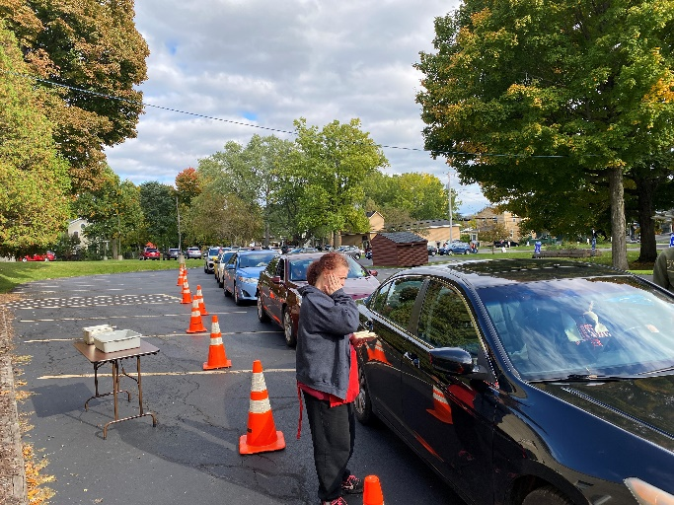
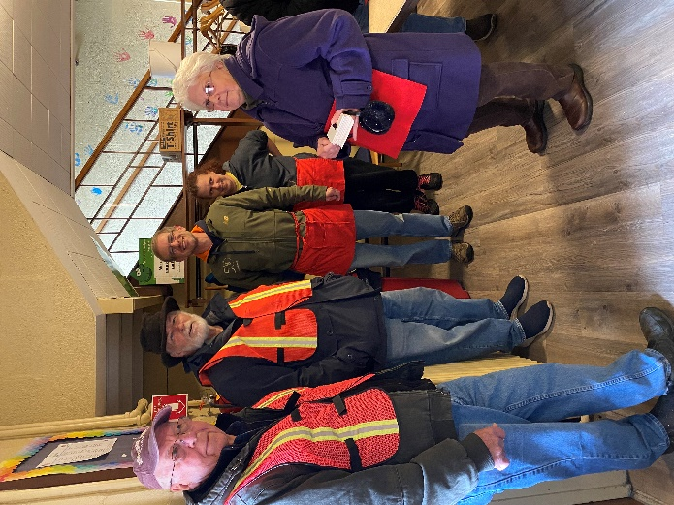

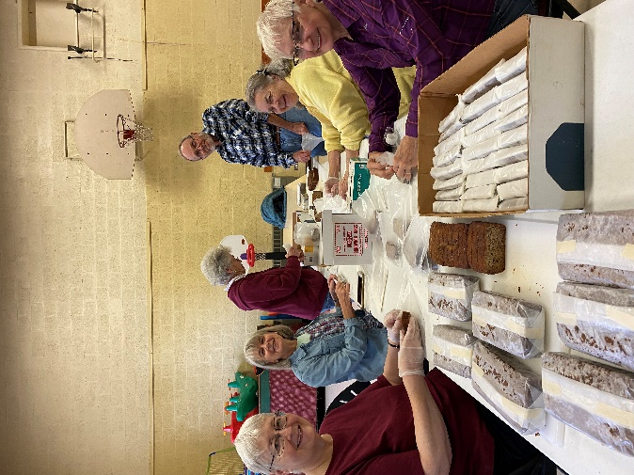

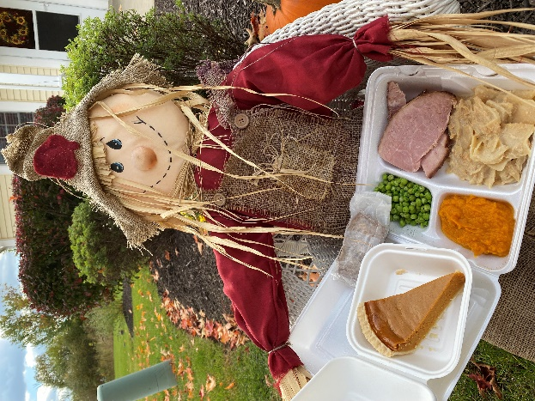

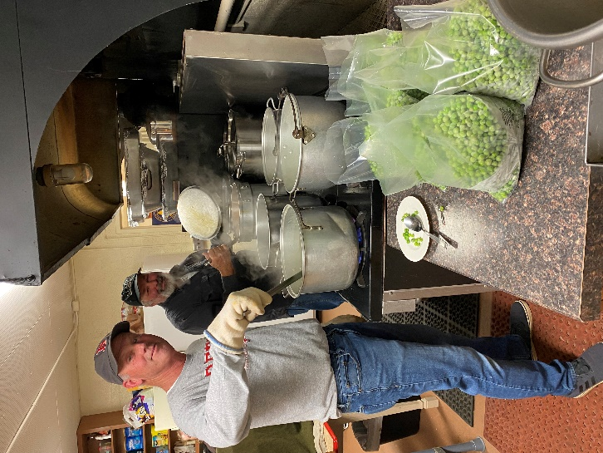

“Look After the World for God”
On Being a Steward

The First Presbyterian Church of Baldwinsville formally began its Stewardship Campaign on Sunday, October 30, 2022 with a sermon from the Rev. Karen Chamis.

As we open our hearts and minds to the abundant season to come, may we also focus on thankfulness, kindness, generosity, and responsibility for the many programs our church offers. Those receiving our care and attention rely on us to be responsible stewards and as we have all received so much, we vow to give back in abundance.

What is a steward? We all consider this term at some point. History shows the first known use of the term” stewardship” was as late as the 15th century. Today’s definition suggests “the careful and responsible management of something entrusted to one’s care” Again, scripture tells us;

“Everything you have belongs to God. In everything you do, and with every decision you make, look first to how you can serve the Lord.”

The church needs consistent funding for those entrusted to the care and ministry we give. It is through our programs and general ministry that we offer assistance. As faithful stewards of God’s grace in its various forms, we rely on you, our congregation, to accept the responsibility that God has given us here on earth. (1 Peter 4:10)

-The Stewardship Committee

Grounds Clean-up!

Grounds Clean-up is scheduled for Sunday, November 6 after Church. Pizza and refreshments will be served after. A rain date is scheduled for Saturday, November 12 at 9 a.m. Come get some fresh air and exercise with your Church friends!

Quarterly statements for your contributions and offerings were emailed the first week in October (from giving@presbville.com). If you didn't receive a copy or if you noticed an omission, check your junk email folder, contact the church office or email giving@presbville.com.

Thanks,

Andy Brussel, Elder
Budget and Finance Committee

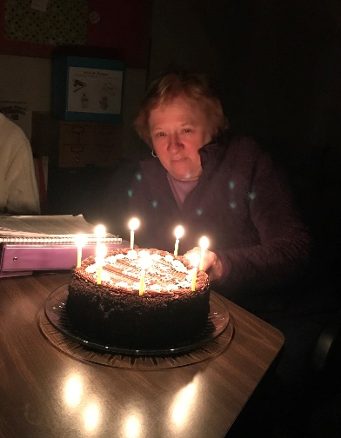
Our October Deacon’s meeting happened to fall on the birthday of our fearless leader and moderator, Marty Pond. We celebrated with cake and coffee! Happy belated birthday, Marty!

New Address

Bob Lasher
Brookdale Bellevue, Room 49
4330 Onondaga Blvd
Syracuse, NY 13219

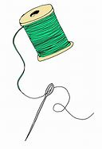
Do you have extra sewing material that you would like to donate to make Walker Bags? Our own Nancy Landon has offered to make bags for individuals that utilize walkers. Please drop off any material to the church office. Thank you!

